Assignment 5
Yaoding Chen

Colab Notebook: https://colab.research.google.com/drive/1efbGebQRuS0KocFPi-LYJCOA9OMQWoso?usp=sharing

### Question 1
Use the data from Homework 4 to train random forest classification models for each of the 5 different tumor types:
a. breast (BRCA),
b. colon (COAD),
c. kidney (KIRC),
d. lung (LUAD),
e. prostate (PRAD).

For each model:
i. explain your choice of the parameters ntree and mtry,
ii. report the confusion matrix,
iii. use the feature importance rankings for each model to extract the top genes (features) that classify each tumor type.

Before we start, we find that there might be issues with imbalance class labels, so we use both oversample and undersample to re-create new datasets that allows balanced class label number. Here is an illustration of dataset resampling in COAD dataset.
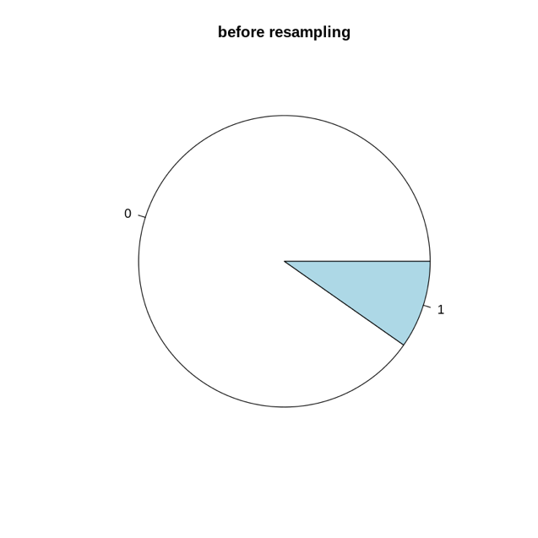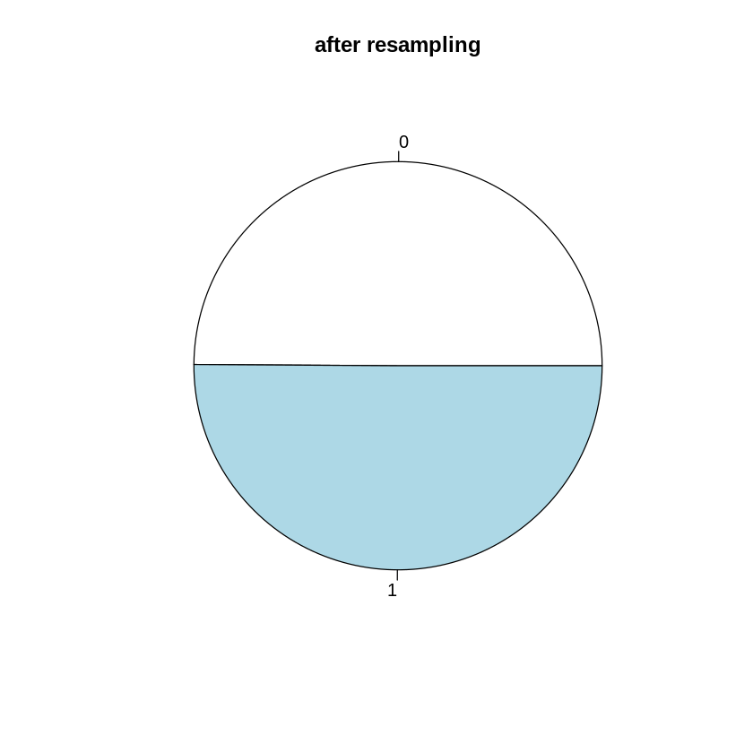

Here it has been asserted that tune ntree parameter is not helpful, if ntree is large enough already. The point here is that the average of different tree votes will approach mean prediction value if the number of tree approaches infinity, due to the Weak Law of Large Numbers. So it is only helpful if we can make ntree a large number, but not too large as that would increase computing time.

RandomForest in R can run in default mode, which in our case set ntree = 500, mtry = 10. The results are pretty good already, and I personally think tuning is not important here.
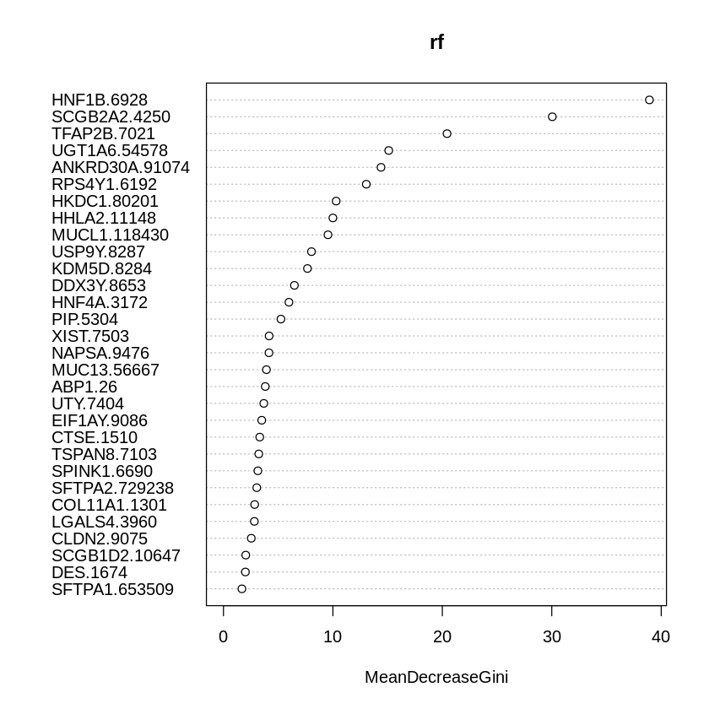
Below are the result of BRCA (default),
Call:
randomForest(formula = Class ~ ., data = train)
Type of random forest: classification
Number of trees: 500
No. of variables tried at each split: 10

OOB estimate of error rate: 0.17%
Confusion matrix:
0 1 class.error
0 376 0 0.000000000
1 1 224 0.004444444
pred
0 1
0 125 0
1 1 74


COAD (default):
Call:
randomForest(formula = Class ~ ., data = train)
Type of random forest: classification
Number of trees: 500
No. of variables tried at each split: 10

OOB estimate of error rate: 0.33%
Confusion matrix:
0 1 class.error
0 542 0 0.00000000
1 2 56 0.03448276
pred
0 1
0 181 0
1 0 20

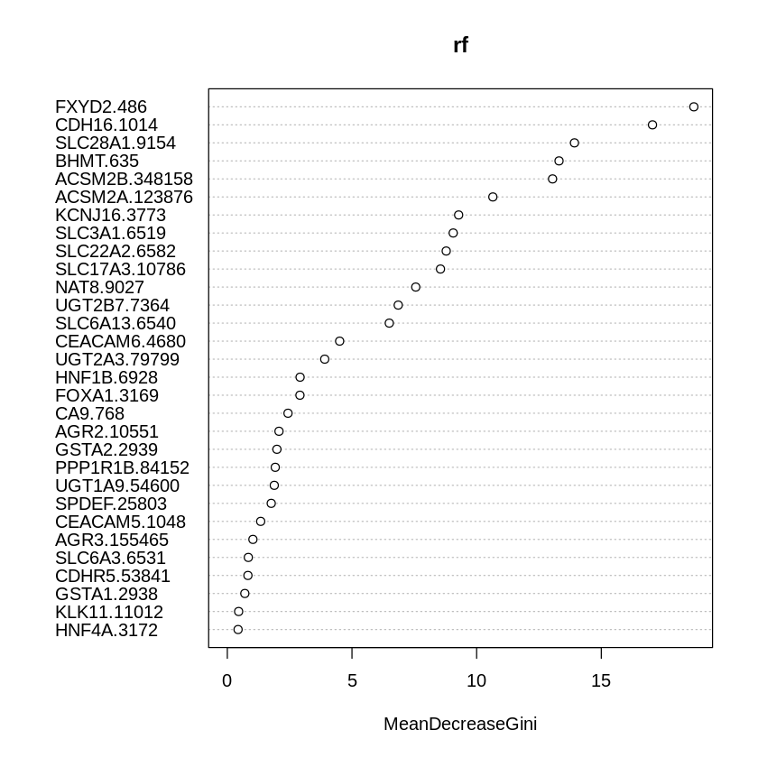
KIRC (default):
Call:
randomForest(formula = Class ~ ., data = train)
Type of random forest: classification
Number of trees: 500
No. of variables tried at each split: 10

OOB estimate of error rate: 0.17%
Confusion matrix:
0 1 class.error
0 491 0 0.000000000
1 1 109 0.009090909
pred
0 1
0 164 0
1 0 36

LUAD (default):
Call:
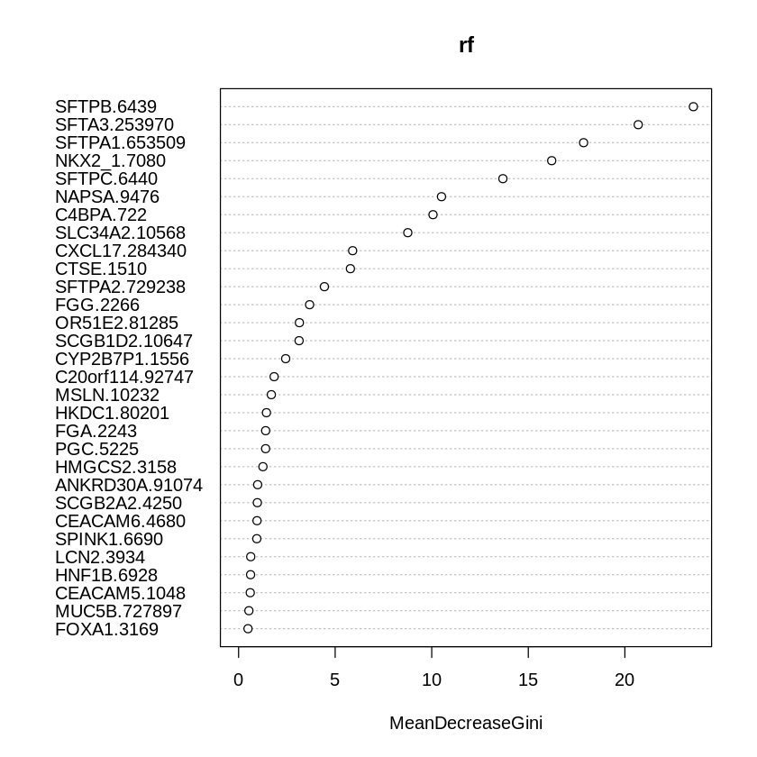
randomForest(formula = Class ~ ., data = train)
Type of random forest: classification
Number of trees: 500
No. of variables tried at each split: 10

OOB estimate of error rate: 0.83%
Confusion matrix:
0 1 class.error
0 495 0 0.00000000
1 5 101 0.04716981
pred
0 1
0 165 0
1 1 34
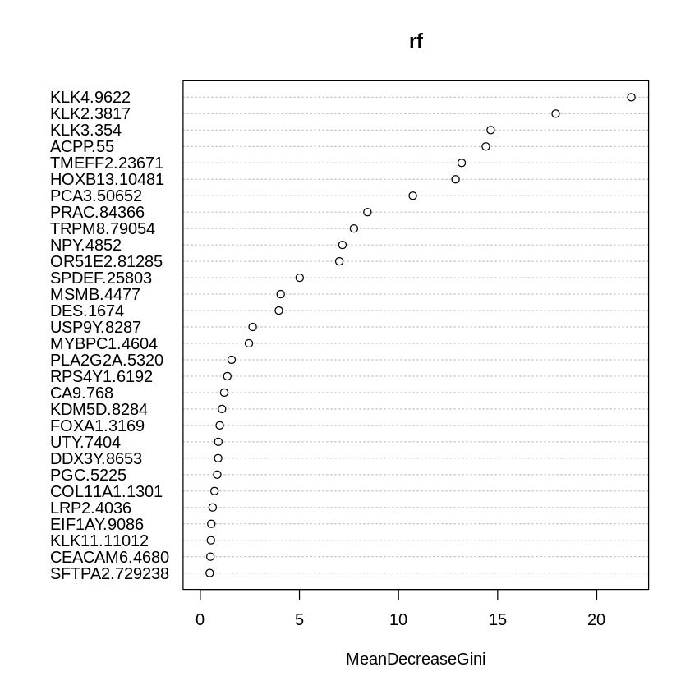
PRAD (default):
Call:
randomForest(formula = Class ~ ., data = train)
Type of random forest: classification
Number of trees: 500
No. of variables tried at each split: 10

OOB estimate of error rate: 0%
Confusion matrix:
0 1 class.error
0 499 0 0
1 0 102 0
pred
0 1
0 166 0
1 0 34
The parameter mtry means the number of variables randomly sampled as candidates at each split, which is available for tuning. There are two simple ways proposed for tuning this parameter, i.e. random search and grid search and in my experiments, they give the similar result. For example, in the case of COAD, both methods suggest mtry should be a range between 2 and 16. Details of the hyperparameter tuning can be found in my Notebook. An example result of random search is shown on the left and an example result of grid search on the right. They have similar curve but grid search is in higher resolution, indicating a lot of local minima which random search fails to spot.
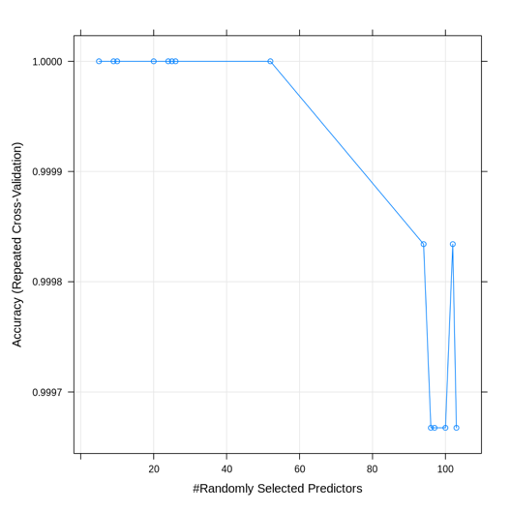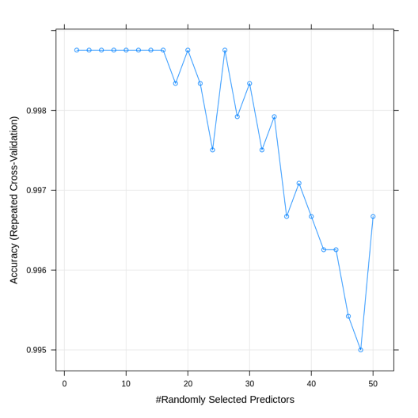

For BRCA, the best mtry is 2 as shown in the figure on the left below. For COAD, the best mtry is also 2, as shown in the figure on the right below. Yet mtry = 10 is still within the optimal range.

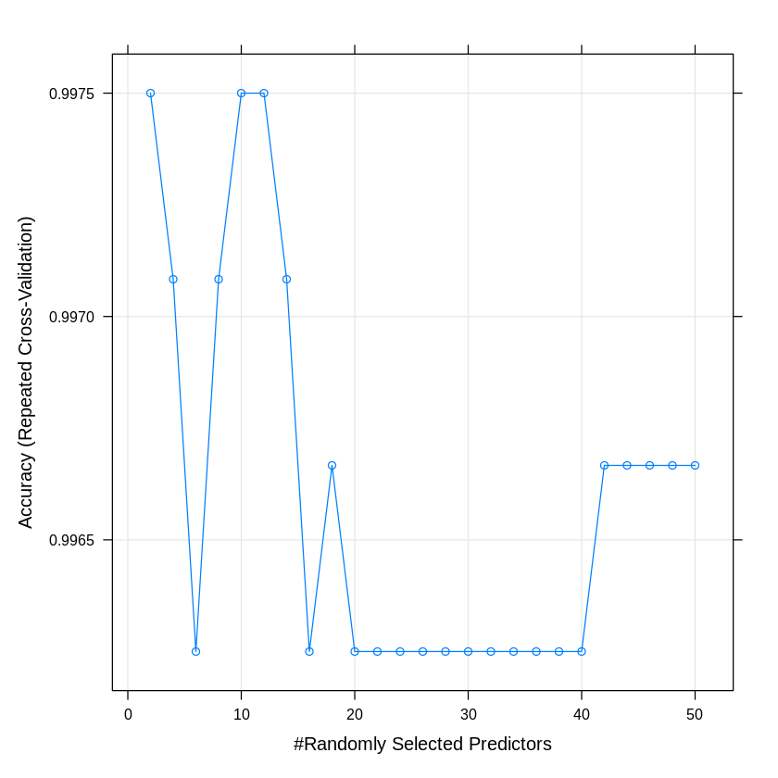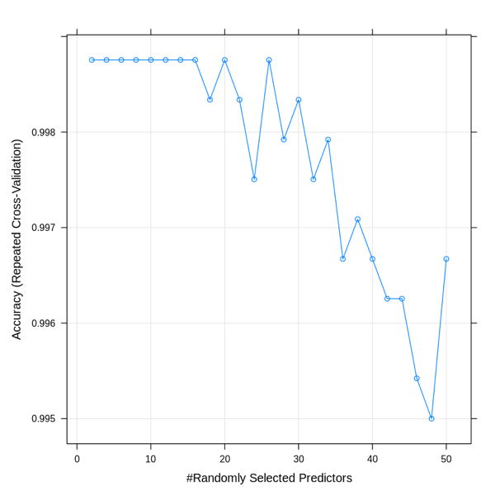
For KIRC, the best mtry is 4 as shown in the figure on the left below, whereas mtry = 10 is still within the optimal range.. For LUAD, the best mtry is 2, as shown in the figure on the right below. This is consistent with the observation that when setting mtry to 10, which is not within the optimal range, the classifier make wrong classification. So here we re-train the model with the optimal parameter, but the improvement is not as significant as expected, so we just leave it there.
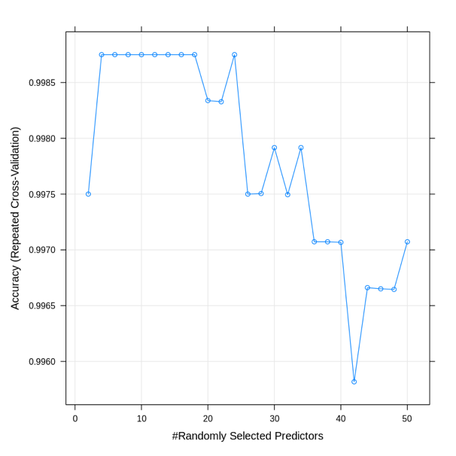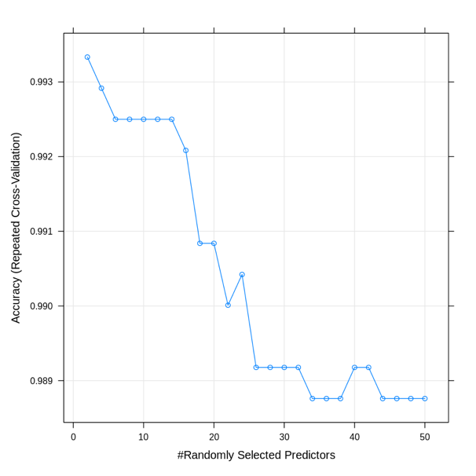
Call:
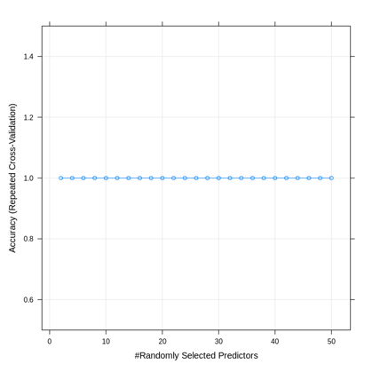
randomForest(formula = Class ~ ., data = train, mtry = 2)
Type of random forest: classification
Number of trees: 500
No. of variables tried at each split: 2

OOB estimate of error rate: 0.67%
Confusion matrix:
0 1 class.error
0 495 0 0.00000000
1 4 102 0.03773585
pred
0 1
0 165 0
1 1 34

The model tuning of random forest classifier for PRAD looks weird, since the result is not sensitive to mtry values. The data could have some clear link to the disease.

### Question 2
For each of the 5 tumour types:
a. Use enrichr to find the significant pathways (using KEGG) and ontologies (using GO Biological Process and GO Molecular Function) that are enriched from your list of important genes.
b. From these enrichments, suggest which of the hallmarks of cancer may be the likely cause of cancer.
c. From these hallmarks, suggest potential drugs that may be used to treat each type of cancer. (5 points)

I used clusterProfiler to find the significant enriched terms or pathways. There are some enriched terms but few are significantly enriched after multiple testing correction, even though I have lowered the criteria. Below shows different drugs targeting different cancer hallmarks, where we can find the corresponding drug for different hallmarks.

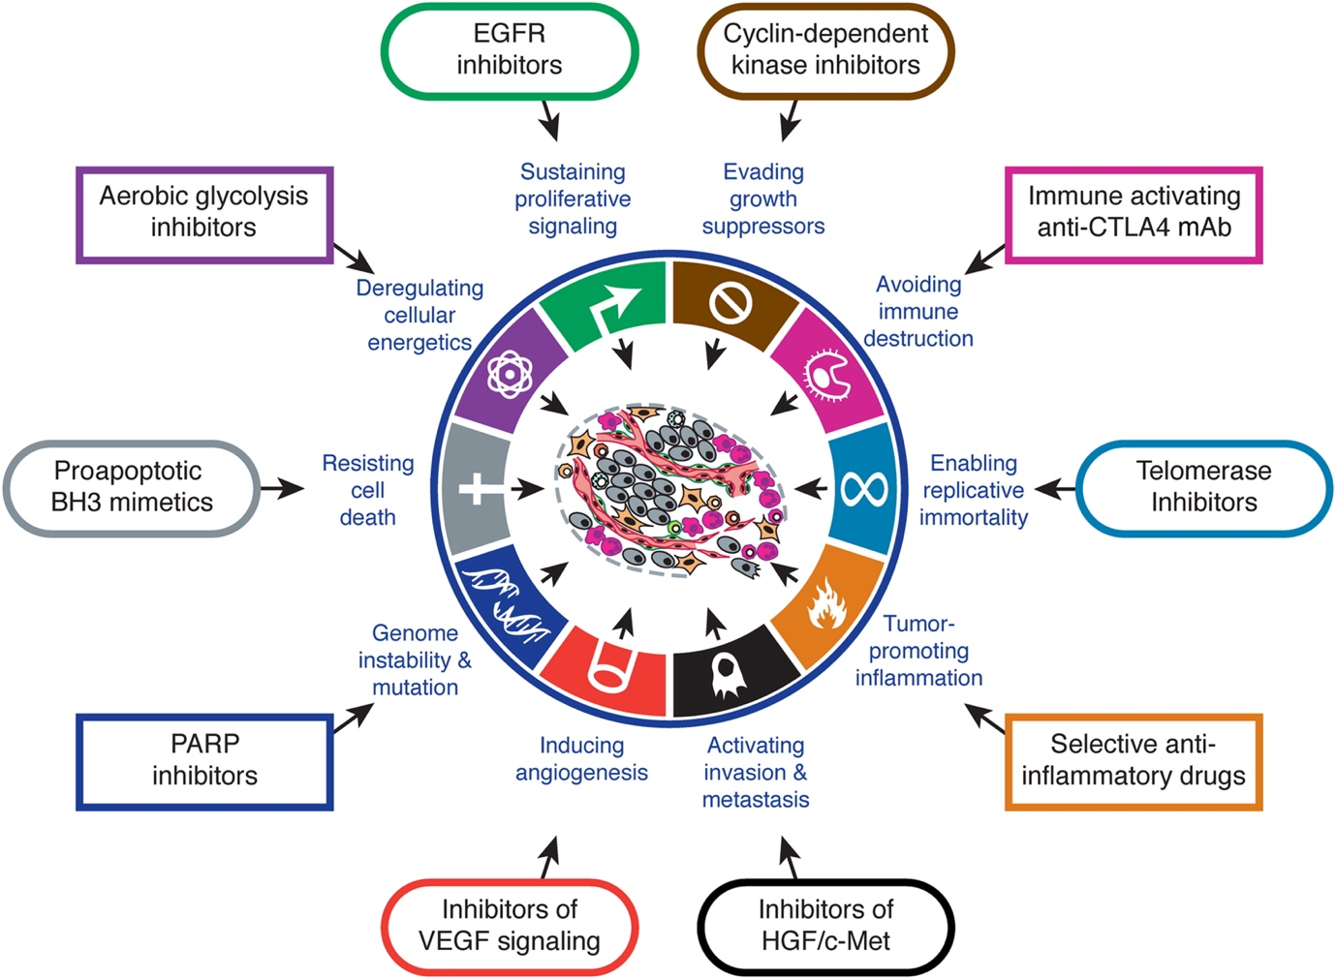

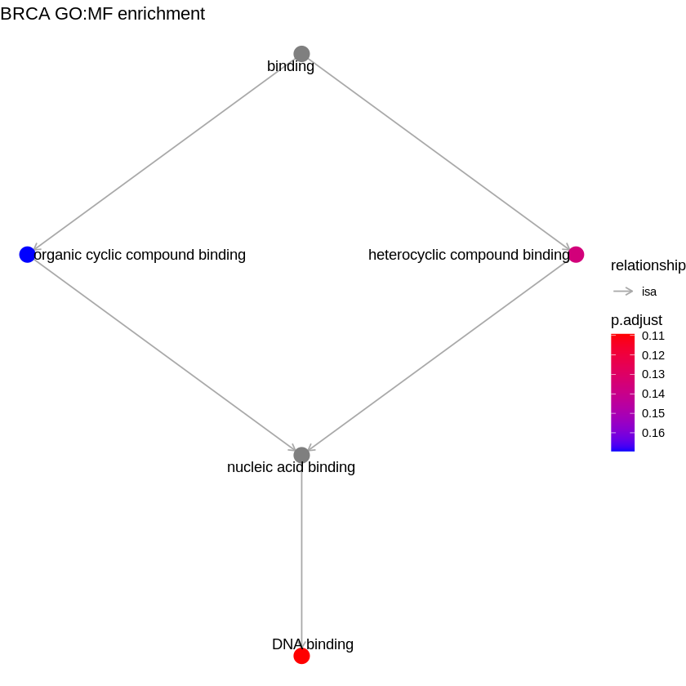

Here the enriched terms in BRCA suggests a link to organic structure binding, which seems to be more related to cellular energetics, so aerobic glycolysis inhibitors, such as 3-BrPA and 2-DG, may be potential drugs.

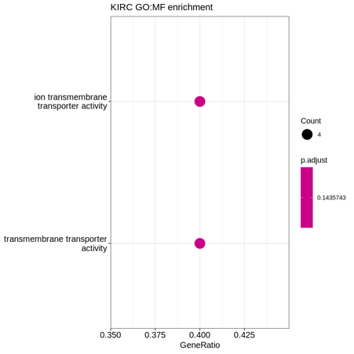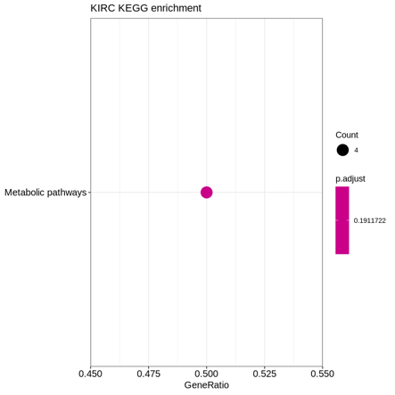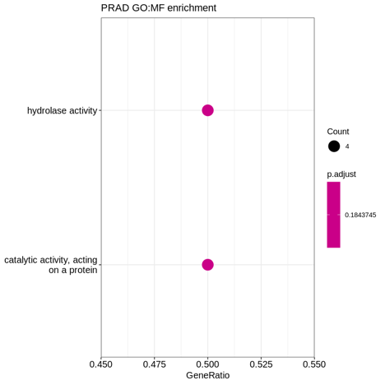
Here is the same to KIRC and PRAD, where cellular energetics is not working well. There no significantly enriched terms observed in other types of cancers, which is maybe a result of my gene choice being too few (N=103).

Using enrichr, we can further look at the enrichment results, without considering p-value issues. Below is the result of BRCA, which suggests further link to genomic instability, in addition to problematic cellular energetics.

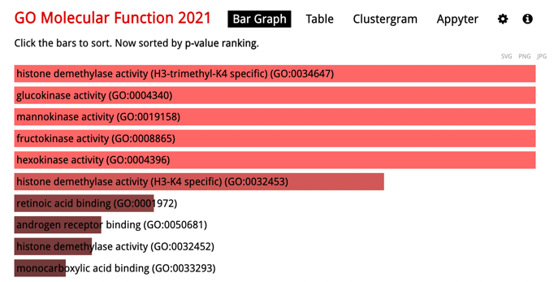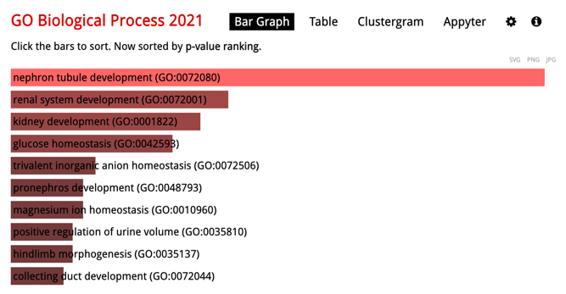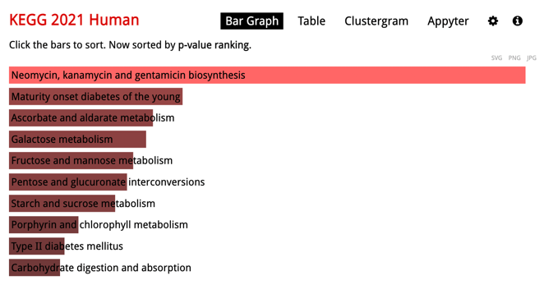

The result of COAD shows that a link with epithelial mesenchymal transition, which suggests its ability to promote tumour with inflammation, which accordingly can be treated with certain anti-inflammatory drugs.

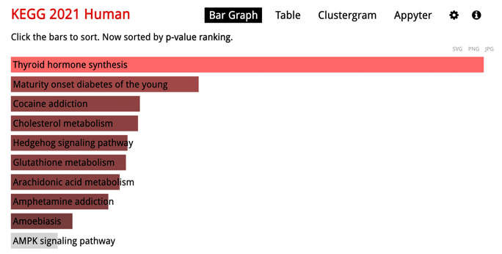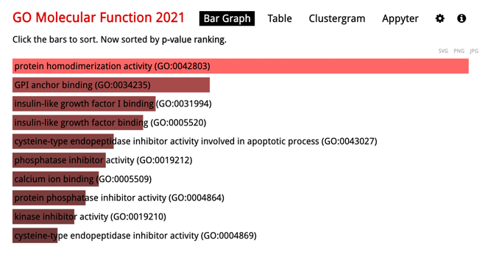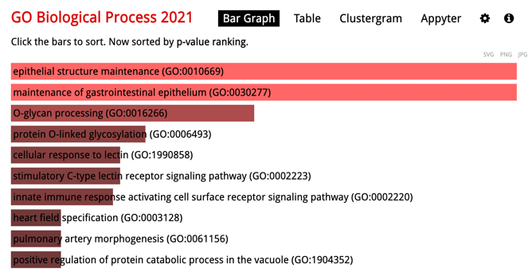

The result of KIRC again shows a link with metabolism, which can be treated with aerobic glycolysis inhibitors as previously discussed.
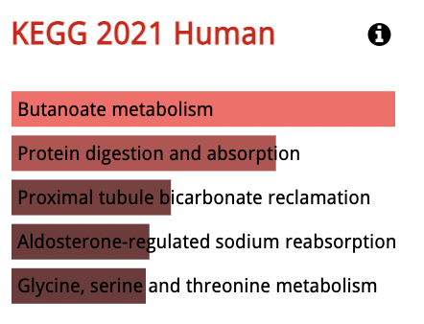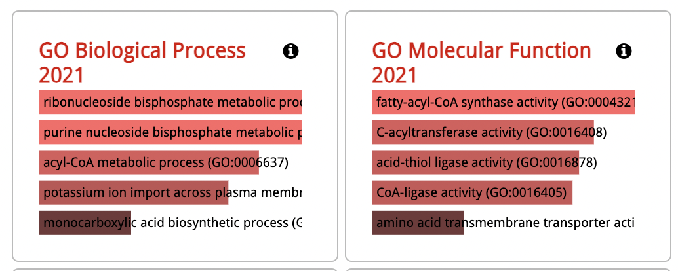
So is the result of LUAD, which is linked to metabolism issues.
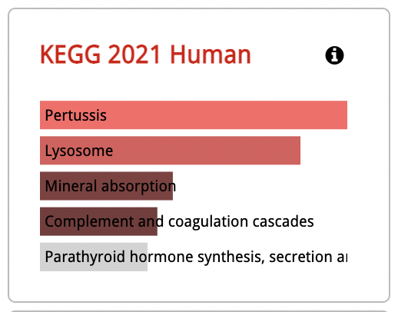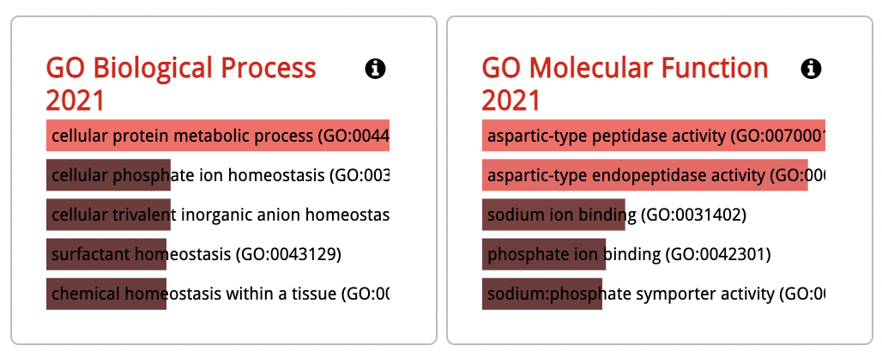

PRAD shows a link with the endocrine system, which suggests the cancer’s ability to create a favourable environment allowing themselves to live, and could be linked to immune evasion.
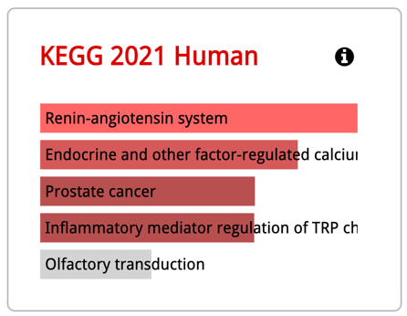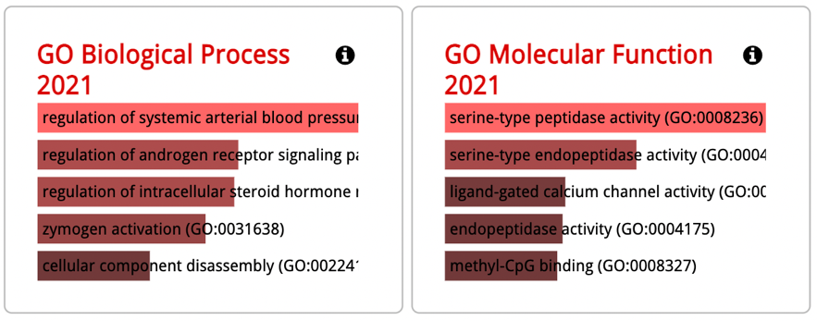

https://stats.stackexchange.com/questions/348245/do-we-have-to-tune-the-number-of-trees-in-a-random-forest
https://machinelearningmastery.com/tune-machine-learning-algorithms-in-r/
https://www.cell.com/fulltext/S0092-8674(11)00127-9
http://www.informatics.jax.org/vocab/gene_ontology/GO:1901363
https://www.nature.com/articles/1209597

